*A*

*Report*

*Submitted in partial fulfilment of the Requirements for the award of the Degree of* **BACHELOR OF ENGINEERING**

IN

## INFORMATION TECHNOLOGY

By

B.NIKHITA: 1602-19-737-084



**Department of Information Technology**

**Vasavi College of Engineering(Autonomous)**

**(Affiliated to Osmania University)**

**Ibrahimbagh, Hyderabad-31**

**BONOFIED CERTIFICATE**

This is to certify that the project report titled “**Music Mania**” project work of B.Nikhita bearing hall ticket number 1602-19-737-084 who carried out this project under my supervision the IV semester for the academic year 2020-21

**Signature** **Signature**

**External Examine** B.Leelavathy

Assistant professor

ABSTRACT:-

Music mania is an application designed to provide maintenance of music related database. It has the information regarding users, artists and albums, songs. Users can access their playlist, downloaded songs and albums present in the application .This project has 9 tables .When you enter the data it is stored in the data base and is displayed as of when it is needed.

**SOFTWARE USED:**

Java Eclipse, Oracle 11g Database, Java SE version 7, SQL*Plus.

**SQL:**

Structure Query Language(SQL) is a database query language used for storing and managing data in Relational DBMS. SQL was the first commercial language introduced for E.F Codd's **Relational** model of database. Today almost all RDBMS (MySql, Oracle, Infomix, Sybase, MS Access) use **SQL** as the standard database query language. SQL is used to perform all types of data operations in RDBMS.

REQUIREMENT ANALYSIS

List of tables:

*Music_mania*

*Users*

*Songs*

*Artist*

*Albums*

*Your_library*

*Music_artists*

*Music_users*

*Composed*

*Users_library*

*Album_songs*

List of attributes with their domain types:-

*Users:*

1. *Id_no number(5)*
2. *User_name varchar2(20)*
3. *Premium_type varchar2(20)*

*Songs:*

1. *Song varchar2(20)*
2. *listeners number(5)*
3. *Album_title*

*Artist:*

1. *Artists_name varchar2(20)*
2. *Total_album number(5)*
3. *Label varchar2(20)*

*Albums:*

1. *Album_title varchar2(20)*
2. *No_of_tracks number(5)*
3. *Label varchar2(20)*
4. *streamings number(10)*

*Your_library:*

1. *Id_no number(5)*
2. *Playlists_Song varchar2(20)*
3. *Album_title varchar2(20)*
4. *Playlists_name varchar(20)*

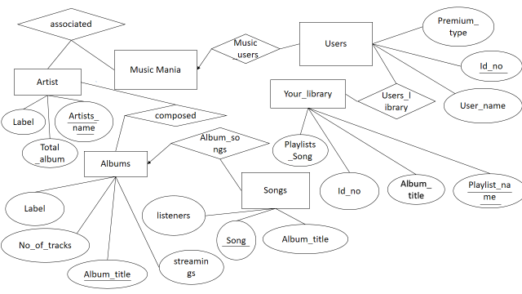

MAPPING CARDINALITY AND PARTICIATION

CONSTRAINTS:

Application can have any number of users, users can have only one account in the application, so it is one to many participation.

Artist can have many albums, album can be composed by many artists by collaborating, so it is many to many participation.

Album can have many songs, a song is present in only one album, so it is one to many participation.

*DDL COMMANDS:*

*create table Artist(*

*Artists_name varchar2(20) primary key ,Total_album number(5) ,Label varchar2(20));*

*create table Albums(*

*Album_title varchar2(20) primary key ,No_of_tracks number(5),Label varchar2(20), Streamings number(10));*

*create table Songs(*

*Song varchar2(20) primary key ,listeners number(5) ,Album_tilte varchar2(20));*

*create table Music_mania(*

*Id_no number(5) ,Artist_name varchar2(20) ,foreign key(Id_no) references Users ,foreign key(Artist_name) references Artist);*

*create table Users(*

*Id_no number(5) primary key ,User_name varchar2(20), Premium_type varchar2(20) );*

*create table Your_library(*

*Id_no number(5) ,Playlist_name varchar2(20)primary key ,Playlists_Song varchar(20) ,Album_title varchar(20));*

*create table User_library(*

*Id_no number(5),Playlist_name varchar2(20), foreign key(Id_no) references Users, foreign key(Playlist_name) references Your_library);*

*create table Album_songs(Song varchar2(20), Album_title varchar2(20), foreign key(Song) references Songs ,foreign key (Album_title) references Albums);*

*create table composed(Artists_name varchar2(20) ,Album_title varchar2(20), foreign key(Artists_name) references Artist, foreign key(Album_title) references Albums);*

*DML COMMANDS:*

*insert into Artist values(‘&Artists_name’ ,&Total_album ,’&Label’);*

*insert into Albums values(*

*‘&Album_title’,&No_of_tracks ,’&Label’ ,&Streamings);*

*insert into Songs values(*

*‘&Song’ ,&listeners ,’&Album_tilte’);*

*insert into Users values(*

*&Id_no ,’&User_name’, ‘&Premium_type’);*

*insert into Your_library values(&Id_no,*

*‘&Playlist_name’ ,’&Playlists_Song’ ,’&Album_title’);*

*SCREENSHOTS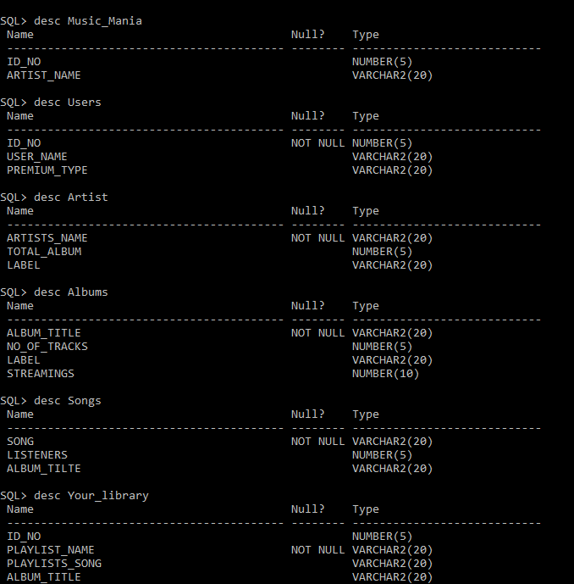*

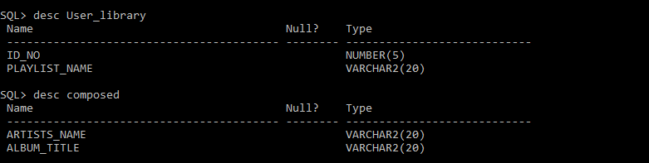

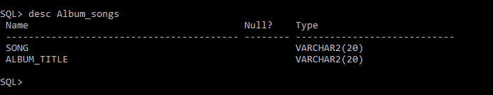

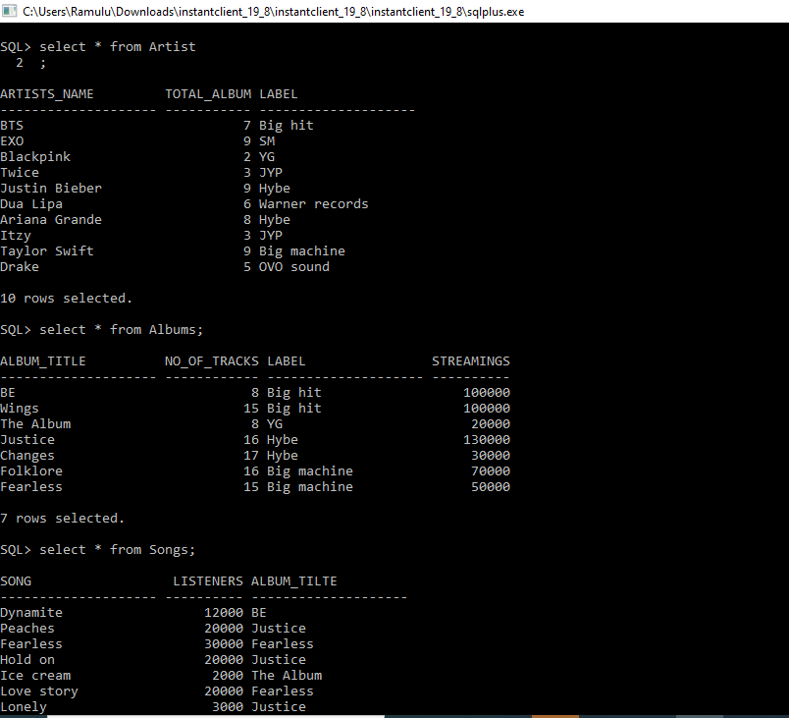

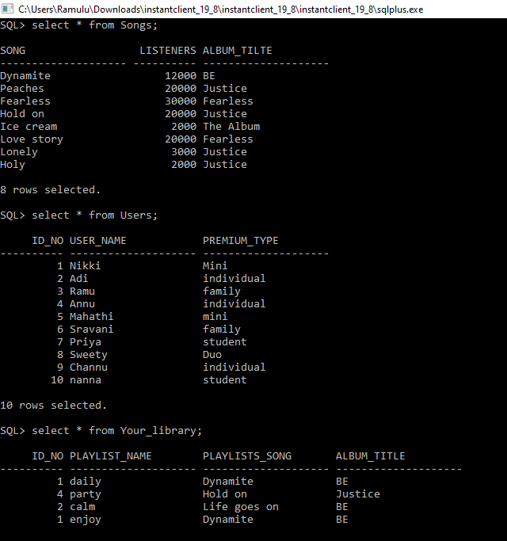

**Java AWT:**

**Java AWT** (Abstract Window Toolkit) is an API to develop GUI or window-based applications in java.

Java AWT components are platform-dependent i.e. components are displayed according to the view of operating system. AWT is heavyweight i.e. its components are using the resources of OS.

The java.awt package provides classes for AWT API such

as TextField, Label, TextArea, RadioButton, CheckBox, Choice, List etc.

PROGRAM:

import java.awt.event.ActionEvent;

import java.awt.event.ActionListener;

import java.sql.*;

import java.text.ParseException;

import java.util.ArrayList;

import java.util.Date;

import javax.swing.*;

import net.proteanit.sql.DbUtils;

public class dbms{

public static void main(String[] args) {

login();

}

}

public static Connection connect()

{

try {

Class.forName("oracle.jdbc.driver.OracleDriver");

Connection con = DriverManager.getConnection("jdbc:oracle:thin:@218.248.0.7:1521:RDBMS","it19737084","vasavi");

//System.out.println("Connected to MySQL");

return con;

}

catch (Exception ex) {

ex.printStackTrace();

}

return null;

}

public static void login() {

JFrame f=new JFrame("Login");//creating instance of JFrame

JLabel l1,l2;

l1=new JLabel("Username"); //Create label Username

l1.setBounds(30,15, 100,30); //x axis, y axis, width, height

l2=new JLabel("Id_no"); //Create label id

l2.setBounds(30,50, 100,30);

JTextField F_user = new JTextField(); //Create text field for username

F_user.setBounds(110, 15, 200, 30);

JTextField F_id=new JTextField(); //Create text field for id

F_id.setBounds(110, 50, 200, 30);

JButton login_but=new JButton("Login");//creating instance of JButton for Login Button

login_but.setBounds(130,90,80,25);//Dimensions for button

login_but.addActionListener(new ActionListener() { //Perform action

public void actionPerformed(ActionEvent e){

String user = F_user.getText(); //Store username entered by the user in the variable "username"

String id = F_id.getText(); //Store id entered by the user in the variable "id”

if(username.equals("")) //If username is null

{

admin_menu();

}

else if(id.equals("")) //If id is null

{

admin_menu();

}

else { //If both the fields are present then to login the user, check wether the user exists already

//System.out.println("Login connect");

Connection connection=connect(); //Connect to the database

try

{

Statement stmt = connection.createStatement();

stmt.executeUpdate("USE Music_Mania"); //Use the database with the name "Music_Maina"

String st = ("SELECT * FROM USERS WHERE USER_NAME='"+username+"' AND ID_NO='"+id+"'"); //Retreive username and id from users

ResultSet rs = stmt.executeQuery(st); //Execute query

if(rs.next()==false) { //Move pointer below

System.out.print("No user");

JOptionPane.showMessageDialog(null,"Wrong Username/id!"); //Display Message

}

else {

user_menu();

}

}

catch (Exception ex) {

ex.printStackTrace();

}

}

}

});

f.add(F_id); //add password

f.add(login_but);//adding button in JFrame

f.add(F_user); //add user

f.add(l1); // add label1 i.e. for username

f.add(l2); // add label2 i.e. for id

f.setSize(400,180);//400 width and 500 height

f.setLayout(null);//using no layout managers

f.setVisible(true);//making the frame visible

f.setLocationRelativeTo(null);

}

public static void create() {

Connection connection=connect();

Statement stmt = connection.createStatement();

String sql = "CREATE DATABASE Music_Mania";

stmt.executeUpdate(sql);

stmt.executeUpdate("USE Music_Mania");

//Create Users Table

String sql1 = ("CREATE TABLE USERS(ID_NO NUMBER(5) PRIMARY KEY, USER_NAME VARCHAR2(20),PREMIUM_TYPE VARCHAR2(20))");

stmt.executeUpdate(sql1);

//Create artists table

stmt.executeUpdate("CREATE TABLE ARTIST(ARTISTS_NAME VARCHAR2(20) PRIMARY KEY, TOTAL_ALBUM NUMBER(5), LABEL VARCHAR2(20))");

//Create albums Table

stmt.executeUpdate("CREATE TABLE ALBUM(ALBUM_TITLE VARCHAR2(20) PRIMARY KEY, NO_OF_TRACKS NUMBER(5),LABEL VARCHAR2(20),STREAMINGS NUMBER(10))");

//create songs table

stmt.executeUpdate("CREATE TABLE SONGS(SONG VARCHAR2(20) PRIMARY KEY, LISTENERS NUMBER (5), ALBUM_TITLE VARCHAR2(20))");

//Create Music_mania table

stmt.executeUpdate("CREATE TABLE MUSIC_MANIA(ID_NO NUMBER(5),ARTIST_NAME VARCHAR2(20),FOREIGN KEY(ID_NO) REFERENCES USERS,FOREIGN KEY(ARTIST_NAME) REFERENCES ARTIST);

//create table Your_library

stmt.executeUpdate("CREATE TABLE YOUR_LIBRARY(ID_NO NUMBER(5),PLAYLIST_NAME VARCHAR2(20) PRIMARY KEY,PLAYLISTS_SONG VARCHAR2(20),ALBUM_TITLE VARCHAR2(20))");

//create table User_library

stmt.executeUpdate("CREATE TABLE USER_LIBRARY(ID_NO NUMBER(5),PLAYLIST_NAME VARCHAR2(20),FOREIGN KEY(ID_NO) REFERENCES USERS,FOREIGN KEY(PLAYLIST_NAME) REFERENCES YOUR_LIBRARY)");

//create table Album_songs

stmt.executeUpdate("CREATE TABLE ALBUM_SONGS(SONG VARCHAR2(20),ALBUM_TITLE VARCHAR2(20),FOREIGN KEY(SONG) REFERENCES SONGS,FOREIGN KEY (ALBUM_TITLE) REFERENCES ALBUMS)");

//create composed table

stmt.executeUpdate("CREATE TABLE COMPOSED(ARTISTS_NAME VARCHAR2(20),ALBUM_TITLE VARCHAR2(20),FOREIGN KEY(ARTISTS_NAME) REFERENCES ARTIST,FOREIGN KEY(ALBUM_TITLE) REFERENCES ALBUMS)");

resultSet.close();

}

catch (Exception ex) {

ex.printStackTrace();

}

}

public static void user_menu() {

JFrame f=new JFrame("User Functions"); //Give dialog box name as User functions

//f.setDefaultCloseOperation(JFrame.EXIT_ON_CLOSE); //Exit user menu on closing the dialog box

JButton Song=new JButton("Songs");//creating instance of JButton

Song.setBounds(20,20,120,25);//x axis, y axis, width, height

Song.addActionListener(new ActionListener() {

public void actionPerformed(ActionEvent e){

JFrame f = new JFrame("Songs"); //View songs in database

Connection connection = connect();

String sql="select * from Songs"; //Retreive data from database

try {

Statement stmt = connection.createStatement();

stmt.executeUpdate("USE Music_Mania");

stmt=connection.createStatement();

ResultSet rs=stmt.executeQuery(sql);

JTable song_list= new JTable(); //show data in table format

song_list.setModel(DbUtils.resultSetToTableModel(rs));

JScrollPane scrollPane = new JScrollPane(song_list); //enable scroll bar

f.add(scrollPane); //add scroll bar

f.setSize(800, 400); //set dimensions of view songs frame

f.setVisible(true);

f.setLocationRelativeTo(null);

} catch (SQLException e1) {

// TODO Auto-generated catch block

JOptionPane.showMessageDialog(null, e1);

}

}

}

);

JButton Album=new JButton("Albums");//creating instance of JButton

Album.setBounds(150,20,120,25);//x axis, y axis, width, height

Album.addActionListener(new ActionListener() { //Perform action

public void actionPerformed(ActionEvent e){

JFrame f = new JFrame("Album"); //View albums

//f.setDefaultCloseOperation(JFrame.EXIT_ON_CLOSE);

Connection connection = connect(); //connect to database

String sql="select * from Albums"; //Retreive data from database

try {

Statement stmt = connection.createStatement(); //connect to database

stmt.executeUpdate("USE Music_Mania"); // use Music_Mania

stmt=connection.createStatement();

ResultSet rs=stmt.executeQuery(sql);

JTable album_list= new JTable(); //show data in table format

album_list.setModel(DbUtils.resultSetToTableModel(rs));

JScrollPane scrollPane = new JScrollPane(album_list); //enable scroll bar

f.add(scrollPane); //add scroll bar

f.setSize(800, 400); //set dimensions of view album frame

f.setVisible(true);

f.setLocationRelativeTo(null);

} catch (SQLException e1) {

// TODO Auto-generated catch block

JOptionPane.showMessageDialog(null, e1);

}

}

}

);

JButton add_playlist=new JButton("Add playlist"); //creating instance of JButton to add playlist

add_playlist.setBounds(20,60,120,25); //set dimensions for button

add_playlist.addActionListener(new ActionListener() {

public void actionPerformed(ActionEvent e){

JFrame g = new JFrame("Enter playlist "); //Frame to enter playlist details

//g.setDefaultCloseOperation(JFrame.EXIT_ON_CLOSE);

//Create label

JLabel l1,l2,l3,l4;

l1=new JLabel("id"); // label 1 for id no

l1.setBounds(30,15,100,30);

l2=new JLabel("playlist name"); //label 2 for playlistname

l2.setBounds(30,50,100,30);

l3=new JLabel("song name"); //label 3 for song name

l3.setBounds(30,85, 100,30);

l4=new JLabel("album title"); // label 4 for album

l4.setBounds(30,130,100,30);

// set text field for id

JTextField F_id = new JTextField();

F_id.setBounds(110,15,200,30);

//set text field for playlist name

JTextField F_playlist = new JTextField();

F_playlist.setBounds(110, 50, 200, 30);

//set text field for song name

JTextField F_song = new JTextField();

F_song.setBounds(110, 85, 200, 30);

// set text field for album name

JTextField F_album = new JTextField();

F_album.setBounds(110,130,200,30);

JButton create_but=new JButton("Create");//creating instance of JButton for Create

create_but.setBounds(130,130,80,25);//x axis, y axis, width, height

create_but.addActionListener(new ActionListener() {

public void actionPerformed(ActionEvent e){

String id = F_id.getText();

int id_int = Integer.parseInt(id);

String playlist = F_playlist.getText();

String song = F_song.getText();

String album = F_album.getText();

Connection connection = connect();

try {

Statement stmt = connection.createStatement();

stmt.executeUpdate("USE MUSIC_MANIA");

stmt.executeUpdate("INSERT INTO YOUR_LIBRARY(ID_NO, PLAYLIST_NAME, PLAYLISTS_SONG, ALBUM_TITLE) VALUES ('"+id_int+"','"+playlist+"','"+song+"',"+album")");

JOptionPane.showMessageDialog(null,"playlist added!");

g.dispose();

}

catch (SQLException e1) {

// TODO Auto-generated catch block

JOptionPane.showMessageDialog(null, e1);

}

}

});

g.add(create_but);

g.add(a2);

g.add(a1);

g.add(l1);

g.add(l2);

g.add(l3);

g.add(l4);

g.add(F_id);

g.add(F_playlist);

g.add(F_song);

g.add(f_album);

g.setSize(350,200);//400 width and 500 height

g.setLayout(null);//using no layout managers

g.setVisible(true);//making the frame visible

g.setLocationRelativeTo(null);

}

});

}

public static void admin_menu() {

JFrame f=new JFrame("Admin Functions"); //Give dialog box name as admin functions

//f.setDefaultCloseOperation(JFrame.EXIT_ON_CLOSE); //

JButton create_but=new JButton("Create/Reset");//creating instance of JButton to create or reset database

create_but.setBounds(450,60,120,25);//x axis, y axis, width, height

create_but.addActionListener(new ActionListener() { //Perform action

public void actionPerformed(ActionEvent e){

create(); //Call create function

JOptionPane.showMessageDialog(null,"Database Created/Reset!"); //Open a dialog box and display the message

}

});

JButton Song=new JButton("Songs");//creating instance of JButton to view songs

Song.setBounds(20,20,120,25);//x axis, y axis, width, height

Song.addActionListener(new ActionListener() {

public void actionPerformed(ActionEvent e){

JFrame f = new JFrame("Songs");

//f.setDefaultCloseOperation(JFrame.EXIT_ON_CLOSE);

Connection connection = connect(); //connect to database

String sql="select * from Songs"; //select all songs

try {

Statement stmt = connection.createStatement();

stmt.executeUpdate("USE Music_Mania");

stmt=connection.createStatement();

ResultSet rs=stmt.executeQuery(sql);

JTable song_list= new JTable(); //view data in table format

song_list.setModel(DbUtils.resultSetToTableModel(rs));

//mention scroll bar

JScrollPane scrollPane = new JScrollPane(song_list);

f.add(scrollPane); //add scrollpane

f.setSize(800, 400); //set size for frame

f.setVisible(true);

f.setLocationRelativeTo(null);

} catch (SQLException e1) {

// TODO Auto-generated catch block

JOptionPane.showMessageDialog(null, e1);

}

}

}

);

JButton users_but=new JButton("View Users");//creating instance of JButton to view users

users_but.setBounds(150,20,120,25);//x axis, y axis, width, height

users_but.addActionListener(new ActionListener() { //Perform action on click button

public void actionPerformed(ActionEvent e){

JFrame f = new JFrame("Users List");

//f.setDefaultCloseOperation(JFrame.EXIT_ON_CLOSE);

Connection connection = connect();

String sql="select * from Users"; //retrieve all users

try {

Statement stmt = connection.createStatement();

stmt.executeUpdate("USE Music_Mania");

stmt=connection.createStatement();

ResultSet rs=stmt.executeQuery(sql);

JTable users_list= new JTable();

book_list.setModel(DbUtils.resultSetToTableModel(rs));

//mention scroll bar

JScrollPane scrollPane = new JScrollPane(book_list);

f.add(scrollPane); //add scrollpane

f.setSize(800, 400); //set size for frame

f.setVisible(true);

f.setLocationRelativeTo(null);

} catch (SQLException e1) {

// TODO Auto-generated catch block

JOptionPane.showMessageDialog(null, e1);

}

}

}

);

JButton Album=new JButton("View Albums");//creating instance of JButton to view the albums

Album.setBounds(280,20,160,25);//x axis, y axis, width, height

Album.addActionListener(new ActionListener() {

public void actionPerformed(ActionEvent e){

JFrame f = new JFrame("Users List");

//f.setDefaultCloseOperation(JFrame.EXIT_ON_CLOSE);

Connection connection = connect();

String sql="select * from Albums";

try {

Statement stmt = connection.createStatement();

stmt.executeUpdate("USE Music_Mania");

stmt=connection.createStatement();

ResultSet rs=stmt.executeQuery(sql);

JTable album_list= new JTable();

album_list.setModel(DbUtils.resultSetToTableModel(rs));

JScrollPane scrollPane = new JScrollPane(album_list);

f.add(scrollPane);

f.setSize(800, 400);

f.setVisible(true);

f.setLocationRelativeTo(null);

} catch (SQLException e1) {

// TODO Auto-generated catch block

JOptionPane.showMessageDialog(null, e1);

}

}

}

);

JButton add_user=new JButton("Add User"); //creating instance of JButton to add users

add_user.setBounds(20,60,120,25); //set dimensions for button

add_user.addActionListener(new ActionListener() {

public void actionPerformed(ActionEvent e){

JFrame g = new JFrame("Enter User Details"); //Frame to enter user details

//g.setDefaultCloseOperation(JFrame.EXIT_ON_CLOSE);

//Create label

JLabel l1,l2,l3;

l1=new JLabel("ID_NO"); //label 1 for id

l1.setBounds(30,15, 100,30);

l2=new JLabel("Username"); //label 2 for username

l2.setBounds(30,50, 100,30);

l3=new JLabel("Premium type"); // label 3 for premium type

l3.setBounds(30,85,100,30);

//set text field for id no

JTextField F_id = new JTextField();

F_id.setBounds(110, 15, 200, 30);

//set text field for username

JTextField F_user=new JTextField();

F_user.setBounds(110, 50, 200, 30);

// set text field for premium type

JTextField F_premium= new JTextField();

F_premium.setBounds(110,85,200,30);

JButton create_but=new JButton("Create");//creating instance of JButton for Create

create_but.setBounds(130,130,80,25);//x axis, y axis, width, height

create_but.addActionListener(new ActionListener() {

public void actionPerformed(ActionEvent e){

String id = F_id.getText();

int id_int = Integer.parseInt(id);

String user = F_user.getText();

String premium = F_premium.getText();

Connection connection = connect();

try {

Statement stmt = connection.createStatement();

stmt.executeUpdate("USE MUSIC_MANIA");

stmt.executeUpdate("INSERT INTO USERS(ID_NO, USER_NAME ,PREMIUM_TYPE) VALUES ('"+id_int+"','"+user+"',"+premium+")");

JOptionPane.showMessageDialog(null,"User added!");

g.dispose();

}

catch (SQLException e1) {

// TODO Auto-generated catch block

JOptionPane.showMessageDialog(null, e1);

}

}

});

g.add(create_but);

g.add(a2);

g.add(a1);

g.add(l1);

g.add(l2);

g.add(l3);

g.add(F_id);

g.add(F_user);

g.add(F_premium);

g.setSize(350,200);//400 width and 500 height

g.setLayout(null);//using no layout managers

g.setVisible(true);//making the frame visible

g.setLocationRelativeTo(null);

}

});

JButton add_song=new JButton("Add song"); //creating instance of JButton for adding songs

add_song.setBounds(150,60,120,25);

add_song.addActionListener(new ActionListener() {

public void actionPerformed(ActionEvent e){

//set frame to enter song details

JFrame g = new JFrame("Enter song Details");

//g.setDefaultCloseOperation(JFrame.EXIT_ON_CLOSE);

// set labels

JLabel l1,l2;

l1=new JLabel("Song name"); //label 1 for song name

l1.setBounds(30,15, 100,30);

l2=new JLabel("Album title"); //label 2 for album

l2.setBounds(30,53, 100,30);

//set text field for song name

JTextField F_sname = new JTextField();

F_sname.setBounds(110, 15, 200, 30);

//set text field for album

JTextField F_albumtitle=new JTextField();

F_albumtitle.setBounds(110, 53, 200, 30);

JButton create_but=new JButton("Submit");//creating instance of JButton to submit details

create_but.setBounds(130,130,80,25);//x axis, y axis, width, height

create_but.addActionListener(new ActionListener() {

public void actionPerformed(ActionEvent e){

String sname = F_sname.getText();

String albumtitle = F_albumtitle.getText();

int listeners =1000

Connection connection = connect();

try {

Statement stmt = connection.createStatement();

stmt.executeUpdate("USE Music_Mania");

stmt.executeUpdate("INSERT INTO Songs(SONG, LISTENERS, ALBUM_TITLE) VALUES ('"+sname+"','"+listeners+"',"+album_title+")");

JOptionPane.showMessageDialog(null,"song added!");

g.dispose();

}

catch (SQLException e1) {

// TODO Auto-generated catch block

JOptionPane.showMessageDialog(null, e1);

}

}

});

g.add(create_but);

g.add(l1);

g.add(l2);

g.add(F_sname);

g.add(F_albumtitle);

g.setSize(350,200);//400 width and 500 height

g.setLayout(null);//using no layout managers

g.setVisible(true);//making the frame visible

g.setLocationRelativeTo(null);

}

});

JButton add_album=new JButton("Add album"); //creating instance of JButton for adding albums

add_album.setBounds(450,20,120,25);

add_album.addActionListener(new ActionListener() {

public void actionPerformed(ActionEvent e){

JFrame g = new JFrame("Enter album details");

//g.setDefaultCloseOperation(JFrame.EXIT_ON_CLOSE);

// set labels

JLabel l1,l2,l3;

l1=new JLabel("Album name"); //label 1 for album name

l1.setBounds(30,15, 100,30);

l2=new JLabel("no of tracks"); //label 2 for no of tracks

l2.setBounds(30,53, 100,30);

l3=new JLabel("Label");

l3.setBounds(30,85,100,30);

//set text field for album name

JTextField F_album = new JTextField();

F_album.setBounds(110, 15, 200, 30);

//set text field for no of tracks

JTextField F_tracks=new JTextField();

F_tracks.setBounds(110, 53, 200, 30);

//set text field for label

JTextField F_label = new JTextField();

F_label.setBounds(110,85,200,30);

JButton create_but=new JButton("Submit");//creating instance of JButton to submit details

create_but.setBounds(130,130,80,25);//x axis, y axis, width, height

create_but.addActionListener(new ActionListener() {

public void actionPerformed(ActionEvent e){

String albname = F_album.getText();

String tracks = F_tracks.getText();

int tracks_int = Integer.parseInt(tracks);

String label = F_label.getText();

int streamings=1000;

Connection connection = connect();

try {

Statement stmt = connection.createStatement();

stmt.executeUpdate("USE Music_Mania");

stmt.executeUpdate("INSERT INTO ALBUM(ALBUM_TITLE, NO_OF_TRACKS, LABEL, STREAMINGS) VALUES ('"+albname+"','"+tracks_int+"',"+label+"','"+streamings")");

JOptionPane.showMessageDialog(null,"album added!");

g.dispose();

}

catch (SQLException e1) {

// TODO Auto-generated catch block

JOptionPane.showMessageDialog(null, e1);

}

}

});

g.add(l3);

g.add(create_but);

g.add(l1);

g.add(l2);

g.add(F_albname);

g.add(F_tracks);

g.add(F_label);

g.setSize(350,200);//400 width and 500 height

g.setLayout(null);//using no layout managers

g.setVisible(true);//making the frame visible

g.setLocationRelativeTo(null);

}

});

JButton add_artist=new JButton("Add artist details"); //creating instance of JButton for adding artists

add_artist.setBounds(450,20,120,25);

add_artist.addActionListener(new ActionListener() {

public void actionPerformed(ActionEvent e){

JFrame g = new JFrame("Enter artist Details");

//g.setDefaultCloseOperation(JFrame.EXIT_ON_CLOSE);

// set labels

JLabel l1,l2;

l1 = new JLabel("Artist name"); //label 1 for artist name

l1.setBounds(30,15, 100,30);

l2 = new JLabel("label"); //label 2 for label

l2.setBounds(30,53, 100,30);

//set text field for artist name

JTextField F_artist = new JTextField();

F_artist.setBounds(110, 15, 200, 30);

//set text field for label

JTextField F_label = new JTextField();

F_label.setBounds(110, 53, 200, 30);

JButton create_but=new JButton("Submit");//creating instance of JButton to submit details

create_but.setBounds(130,130,80,25);//x axis, y axis, width, height

create_but.addActionListener(new ActionListener() {

public void actionPerformed(ActionEvent e){

String artist = F_artist.getText();

String label = F_label.getText();

int no_albums=1;

Connection connection = connect();

try {

Statement stmt = connection.createStatement();

stmt.executeUpdate("USE Music_Mania");

stmt.executeUpdate("INSERT INTO ARTIST(ARTISTS_NAME VARCHAR2(20) PRIMARY KEY, TOTAL_ALBUM NUMBER(5), LABEL VARCHAR2(20)) VALUES ('"+artist+"','"+label+"',"+no_albums")");

JOptionPane.showMessageDialog(null,"artist added!");

g.dispose();

}

catch (SQLException e1) {

// TODO Auto-generated catch block

JOptionPane.showMessageDialog(null, e1);

}

}

});

g.add(create_but);

g.add(l1);

g.add(l2);

g.add(F_artist);

g.add(F_label);

g.setSize(350,200);//400 width and 500 height

g.setLayout(null);//using no layout managers

g.setVisible(true);//making the frame visible

g.setLocationRelativeTo(null);

}

});

}

}

*Github link:*

*https://github.com/NIKHITA-84/Music_Mania*